**Physically Measured:**

We connected the SAE (shaft angle encoder) to the ESP32 and swung the arm, recording the angle. A picture of the measured theta with time is shown below.

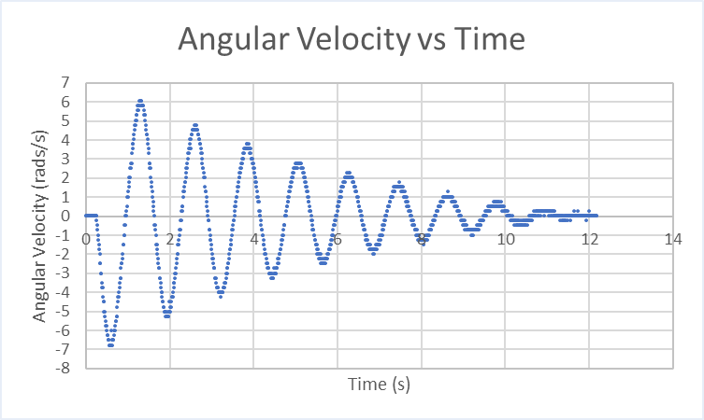

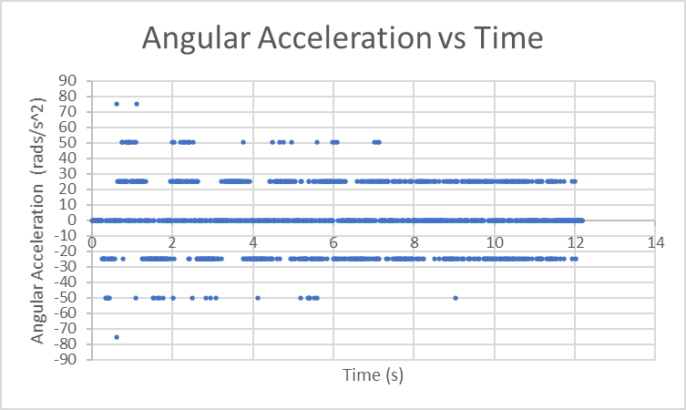

**Simulated:**

After getting physical measurements, we were able to determine more properly what the value of the damping term was and added that to our state-space model. We then adjusted the input to the system to try to get the graph to look as close to that of the physically measured data as possible. Comparing the above images with the ones below, you can see that the they are somewhat identical. This shows that we have accounted for the damping force that is present due to the SAE in our state-space model.

No damping factor:

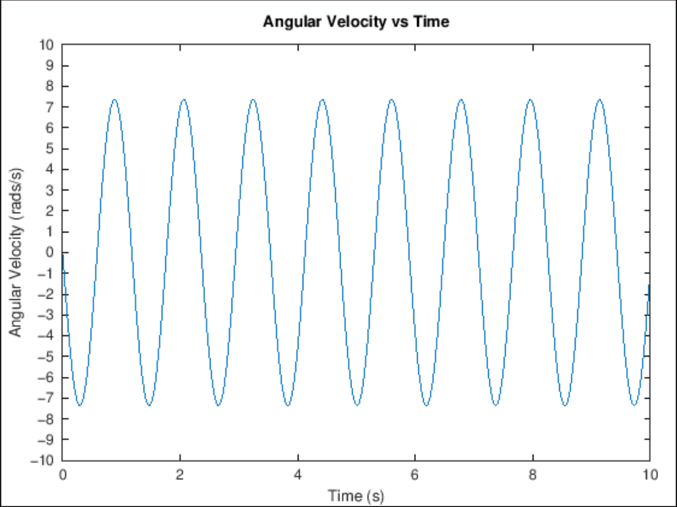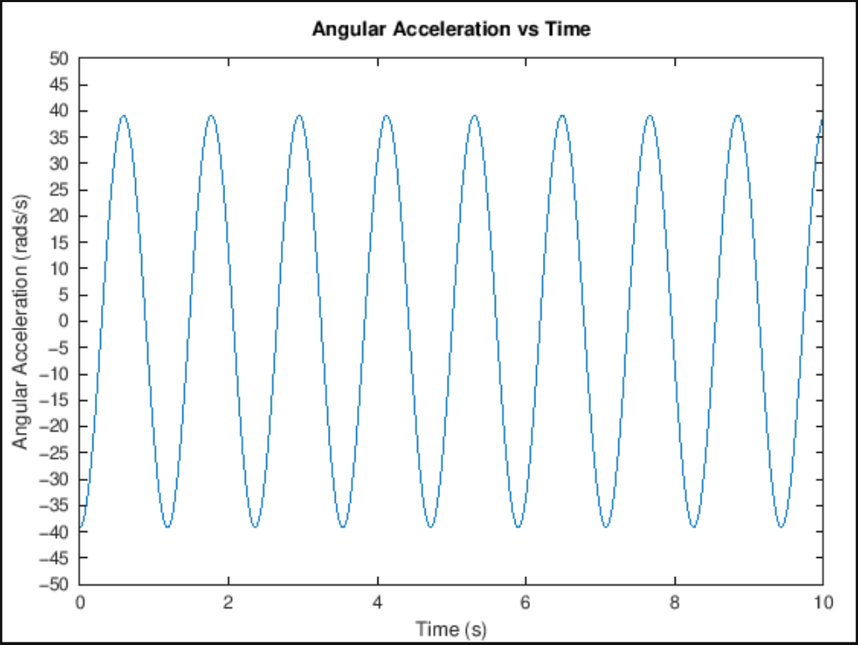

With damping factor of 0.8:

